Creation of EC2 Instance with an AMI using Cloud Formation Template

- Go to Cloud Formation in AWS Console, click create Stack and provide the Cloud Formation S3 template URL and click Next https://s3.amazonaws.com/Technical_Infrastructure/CloudFormation/Create-EC2-Instance-Template1.json

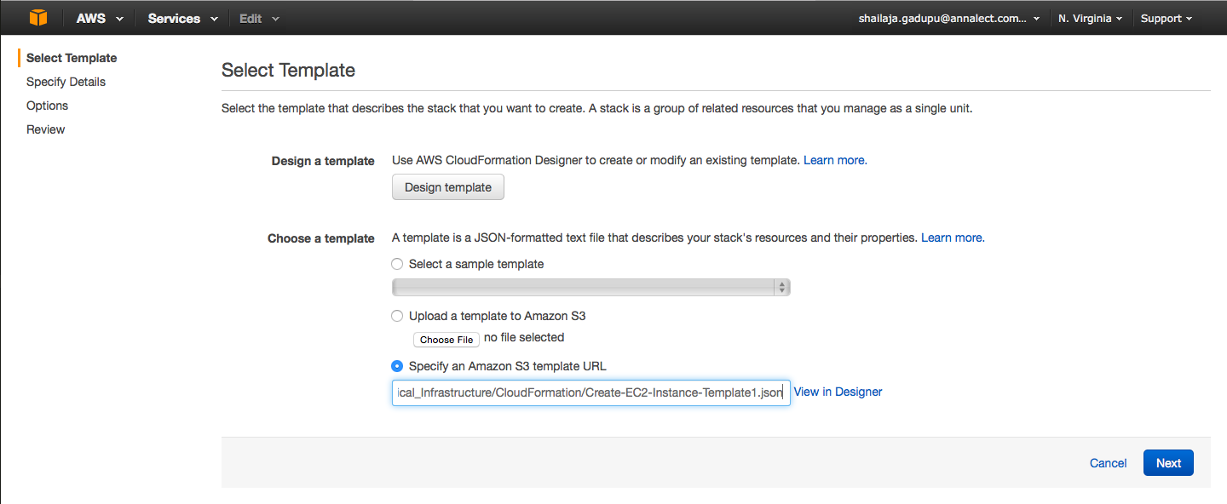

- Refer below points before providing the input parameters and Click Next

Note:
- By default it will display GoldenAMI Ubuntu1404 AMI ID, select that if you want to create EC2 instance with that AMI or provide different AMI as required.
- Provide new IAM role name for every new EC2 instance otherwise by default it will use default IAM role “automationscripts” and later you may not be able to change it manually.
- Based on the Environment and Server Type, appropriate security groups are attached to EC2 instance automatically.

Example: If you choose Environment – Dev, ServerType – web ,
following security groups will be attached automatically. If you want to attach any application specific security group then you should attach it manually.
Environment | ServerType | SecurityGroups
Dev | web | DEV-VPC-Web,  DEV-VPC-MGMT,  Wipro-COC-Access,  TrendMicro-Security-Group,
Dev | app | DEV-VPC-App,  DEV-VPC-MGMT,  Wipro-COC-Access,  TrendMicro-Security-Group,

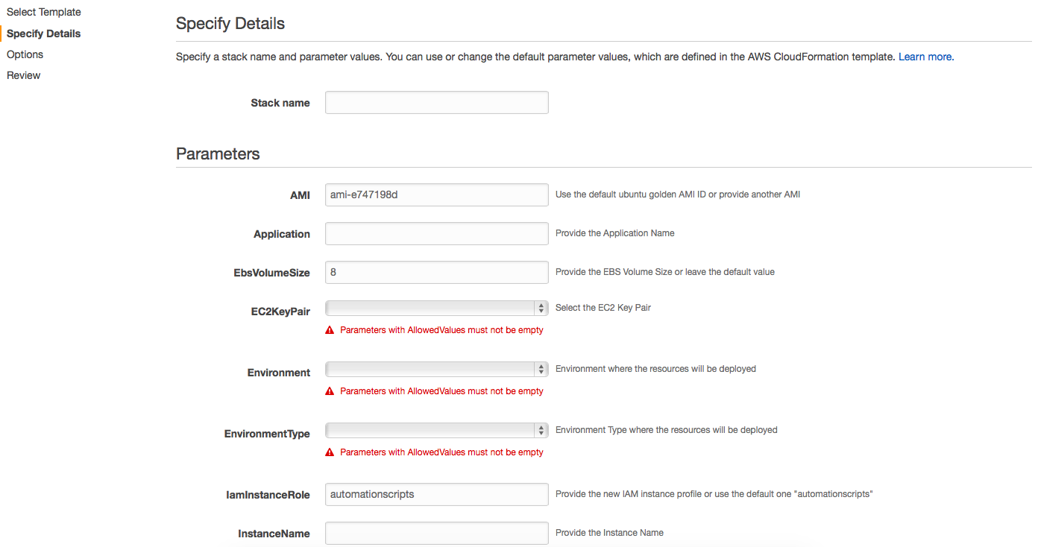

3) Leave the next screen default and Click Next

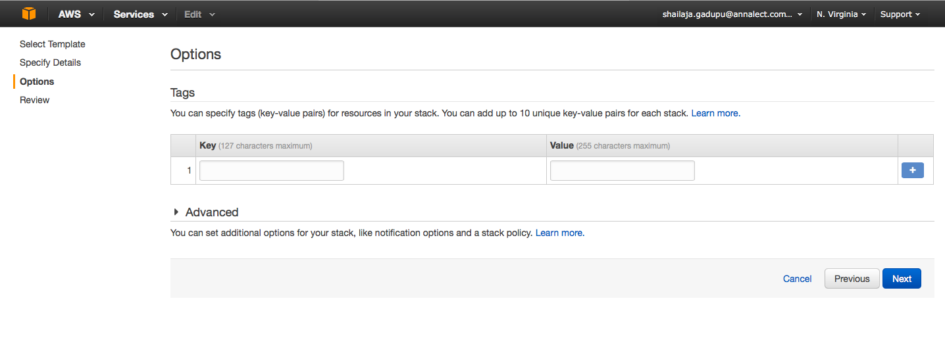

4) Review the parameters, acknowledge the resource creation and Click Create

- Once the Stack created successfully, login to the instance and check if instance setup script run successfully by verifying logs (/var/log/instance-setup.log)

- Following scripts should be run manually on launching new EC2 Instance from hardened AMI

#Ensure the hostname is generated before running host_domain_join
#sudo sh /root/hardening/host_domain_join
#sudo sh /root/hardening/DomainUserRestriction <project_name><dev|qa|prod|mgmt>"
#Install TrendMicro and BMC Agent as required

7) Logout and Login to the instance with annalectww account and verify if you can login successfully.

